Chapter 16, Problem 29.

Calculate i(t) for t > 0 in the circuit in Fig. 16.52.

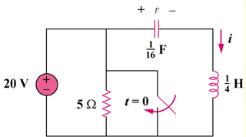
20u(–t) V

5 Ω

Figure 16.52
For Prob. 16.29.

